A Author Recognizer Of Paintings Based On Residual Neural Network

Author: Zhenghui Wang, Ximing Sheng, Zheng Shi, Zhekun Wang, Yuming Yang, Yaxin Hou, Haocheng Xie
Institution: Beijing University of Posts and Telecommunications, Harbin Engineering University, Beijing University of Technology, Beijing Jiaotong University

Abstract

Convolutional neural networks are efficient in image classification, but sometimes they are difficult to train with the increment of the network. To solve the practical artist classification problem more efficiently and quickly, we design and apply a residual neural network to ease the training process which are substantially deeper than traditional convolutional neural networks [2]. We explicitly reformulate the layers as learning residual functions with reference to the layer inputs, instead of learning unreferenced functions [1]. We also provide comprehensive and empirical evidence showing that these residual networks are easier to optimize and train, and can perform quite well from considerably increased depth. On the artist dataset we actually implement a residual net with a depth of up to 9 layers and its highest accuracy can be over 90% on the training set.

We also noticed that the scale of the original dataset is fairly small, generating the phenomenon of over-fitting. To avoid it, we apply the image processing methods, including flip and rotation, to generate more images based on the original image artificially.

Introduction

Recently, the Convolutional Neural Network (CNN) Algorithms achieved good results in many identification fields. Among variable applications, Image classification plays an important role in this technology.

Convolutional Neural Network (CNN)

Convolutional neural networks(CNN) are a class of feed forward neural networks with convolutional computation and deep structure, which is also one of the most important algorithm in the field of Deep Learning. CNN have the ability to represent learning, and can shift-invariant classification of input information according to their hierarchical structure. Therefore, it is also called "Shift-Invariant Artificial Neural Networks (SIANN)". The study of CNN began in the 1980s and 1990s. The time delay network and LeNet-5 were the earliest CNN. After the 21st century, with the introduction of Deep Learning theory and the improvement of numerical computing equipment, the CNN has been rapidly developed and applied to the fields of computer vision, natural language processing, etc.
CNN ’s artificial neurons respond to a surrounding area of a portion of the coverage and perform well for large image processing. It includes a convolutional layer and a pooling layer. The convolution means that feature extraction on the original input. Feature extraction is simply a feature extraction of a small area on the original input, and a detailed explanation of the convolution calculation process. Convolution is not limited to convolutions on the original input.

Contrast between the CNN & Fully CNN
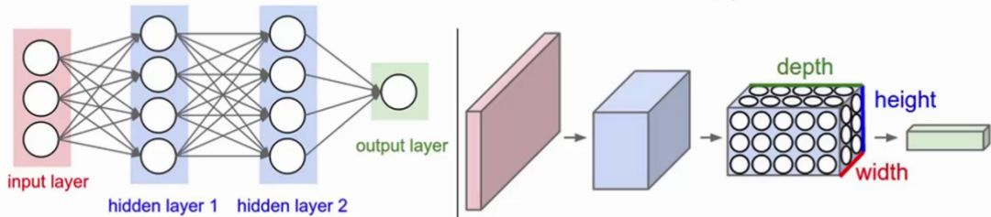
Figure1:Contrast between the CNN(right) & Fully CNN(left)
·The right picture: CNN Composition: input layer, convolution layer, activation function, pooling layer, fully connected layer
· The left picture: Fully CNN Composition: Input layer, activation function, fully connected layer

    - Classic Example of CNN

The following picture is a valid example to understand CNN:
The first convolution can extract low-level features.
The second convolution can extract the features of the middle level.
The third convolution can extract high-level features.
The feature is continuous extraction and compression, and finally can obtain relatively high-level features. In short, the original features are concentrated step by step, and the resulting features are more reliable. Use the last layer of features to do a variety of tasks: classification, regression, and more.
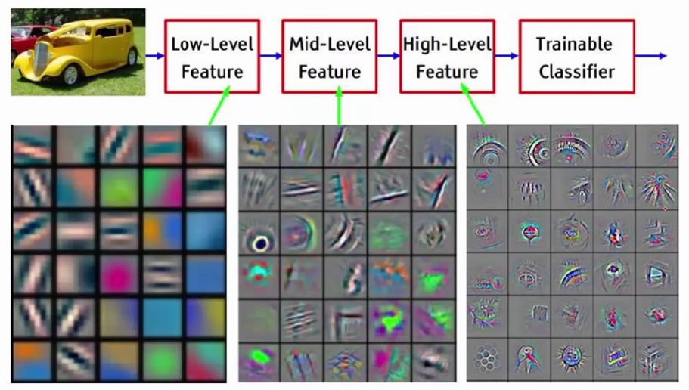
Figure2:A Classic Example of CNN Applications

Image Classification
Image classification is an image processing method that separates different categories of objects according to different characteristics reflected in the image information. It uses a computer to quantitatively analyze an image, and classifies each pixel or region in the image or image into one of several categories instead of human visual interpretation.
For example, as a classic Image Classification model, handwritten numbers for the MNIST database contains 60,000 sample training sets and 10,000 sample test sets. The goal in this training process is to identify each image with its specific label.
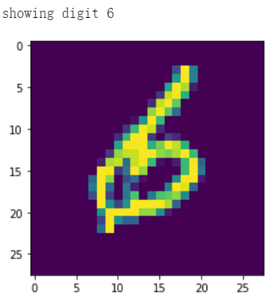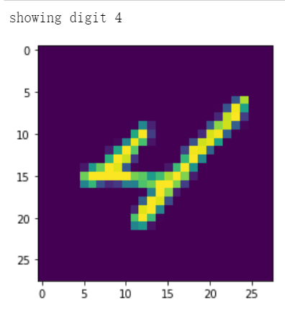
Figure3:The training results of the MNIST database

Blind review
Most Deep Learning researchers first get started with CNN. The first project to start with should be handwritten MNIST digital image recognition. Through this project, the basic operation flow of image classification can be roughly mastered, but because the project is too mature, it is possible to follow the steps. “I only know it but I don’t know why.” Therefore, when encountering other image classification tasks, the researcher may not know how to start, or do not know what kind of pre-training network model to choose, or do not know how to adjust the existing mature model, how to design the number of layers of the model. How to improve the accuracy, etc. These problems are all questions that should be considered when choosing to use the convolutional neural model to complete the image classification task.
When choosing to use CNN for image classification tasks, you need to optimize three main indicators: accuracy, simulation speed, and memory consumption. These performance metrics are closely related to the designed model.

1.5 Summarize

In this paper, we are going to build an image classification program based on the Convolutional Neural Network(CNN) to find out and solve the problems in the whole data processing course. It will be used to identify which artist produced each image.
The composition of the dataset and a sample painting from each artist are shown in the following table which contains 405 works of art from 11 different artists all down sampled and padded to the same size:
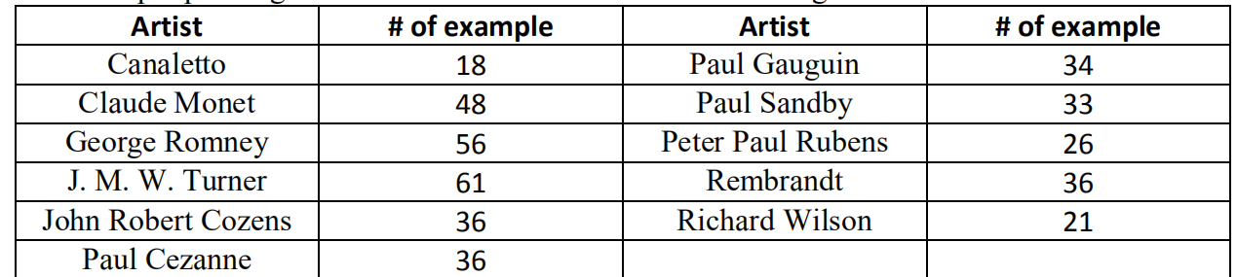
Figure4: The details of the artists and works’ dataset
There is no doubt that we hope the more accurate results we get the better. So, after finishing the whole program, we will still try our best to optimize our code to approach the most accurate result in variable ways.

Method

We start by analyzing the images. In a variety of ways of image enhancement, we try to transform the image to see if there is subjective feature enhancement. Whether you use the pytorch own transform module or custom data enhancement method, It is useful to make reasonable changes to the data in order to enhanced image feature. The most basic changes are simple random flipping, cutting and rotation of the image. Another point to be noted is that the size of the image needs to be changed to meet the input requirements of the model.
Due to the small amount of data obtained, in order to make the training results better, we enhanced the features of the image. We change the size of image and flip the image and process the image by transform.

2.Resnet method
According to the principle of good effect of the new model, we try to select the latest existing model. We select two models with good effect in recent years for testing respectively. At present, the most effective model is ResNet(Residual Neural Network), which is the latest development of convolutional neural network.
ResNet (Residual Neural Network) was proposed by four Chinese people including Kaiming He of Microsoft research institute. Through ResNet Unit, the 152 layer Neural Network was successfully trained and the champion was achieved in ILSVRC2015. The error rate was 3.57% in the top5, and the number of participants was lower than that of VGGNet. The structure of ResNet can accelerate the training of neural network very quickly, and the accuracy of the model has been greatly improved. Meanwhile, the promotion of ResNet is so good that it can even be directly used in InceptionNet network.
The traditional convolutional network or fully connected network has some problem such as information loss and loss during information transmission, and it also leads to gradient disappearance or gradient explosion, which leads to deep network become hard to train. ResNet solves this problem to a certain extent. By bypassing the input information to the output to protect the integrity of the information, the whole network only needs to learn the part of the difference between input and output to simplify the learning objectives and difficulties.
The main idea of ResNet is to add a direct connection channel in the Network, namely the Highway Network. The previous Network structure was a nonlinear transformation of the performance input, while the Highway Network allowed to retain a certain proportion of the output of the previous Network layer. The idea of ResNet is very similar to that of Highway Network, allowing the original input information to be passed directly to the later layers, as shown in the figure below.
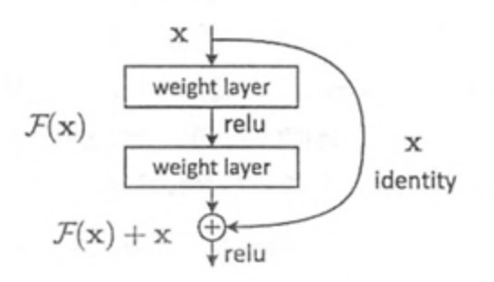
The form of a residual block is defined as y=F(x,Wi)+x, where x and y are the input and output vectors of the residual block respectively. F(x,Wi) is the residual mapping to be learned, and we set it at 2 levels and the σ is a Relu activation function. It is defined as F=W2σ(W1X). The form of the residual function F is flexible. The residual block can also have 3 layers, but if the residual block has only one layer, then y=W1x+x, which is just a linear layer. The residual block of 3 layers is shown as follows.
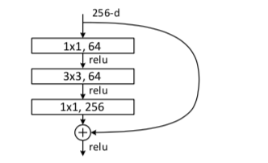
General we call residual block above the 'bottleneck block', here 1 x1 convolution have played an important role in dimension reduction and nonlinear transformation, and the introduction of more significantly increased the depth of the residual block, can improve the expressing ability of residual network.
The difference between the residual network and the ordinary network is the introduction of jump connection, which enables the information of the previous residual block to flow into the next residual block without obstruction, improves the information flow, and avoids the vanishing gradient problem and degradation problem caused by too deep network connection. The residual network is actually formed by the fusion of multiple shallow networks. It does not fundamentally solve the vanishing gradient problem, but only avoids the vanishing gradient problem. Because it is formed by the fusion of multiple shallow networks, the shallow network will not appear the vanishing gradient problem during training, so it can accelerate the convergence of the network.

Experiments

In our experiments, we use the CNN framework of ResNet. We also set the number of batches and epochs also the learning rate according to repeatedly attempts. These hyperparameters enable the loss function to converge successfully during training and result in higher accuracy.

Following graphs show the change process of loss and accuracy:

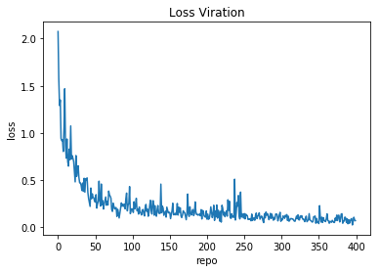
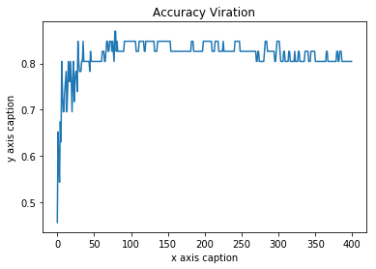

4.1. Dataset

We randomly divide all 405 tagged image data into a training dataset and a test dataset in a ratio of nine to one, so as to timely update the progress and quality of the training. After the data is successfully loaded, a large number of new images are generated by the function of the rotation operation to expand the capacity of the data, thereby achieving better training effects.

4.2. Contrast

When using a relatively simple convolutional neural network with three times convolution and pooling and a fully-connected layer, the final accuracy converged to 0.13.
In testing process the resnet model converaged to 0.70.
This shows that ResNet has achieved relatively excellent training results
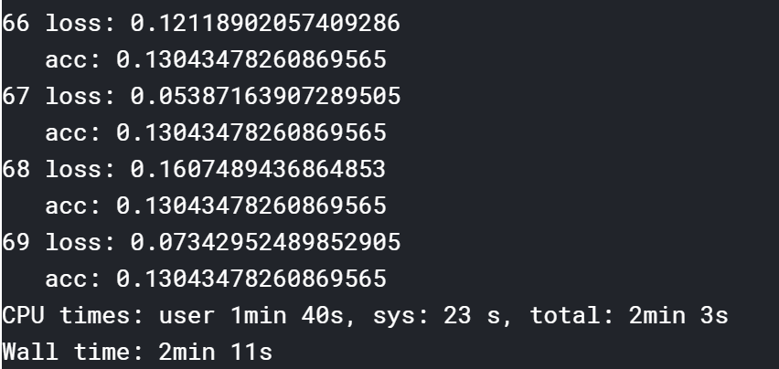
Last accuracy with simple CNN framework

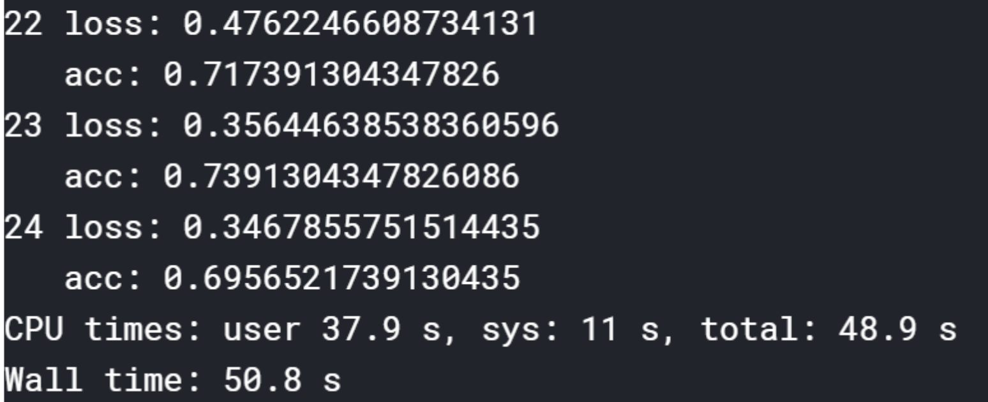
Last accuracy with Resnet framework
4.3. Result

Using trained model to classify images in test set， output a list :
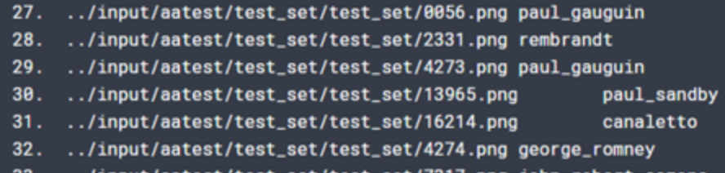
Conclusion

On the basis of our research, the following conclusion can be made: Firstly, we can reinforce the characteristic by resizing and overturning the photograph. Secondly, the structure of ResNet can accelerate the time of drill efficiently and improve the accuracy of the model. We have demonstrated in this paper how the ResNet works and how we improve it. On the artist dataset we implement a residual net with a depth of up to 9 layers and its highest accuracy can be over 90% on the training set.

References

- K. Simonyan and A. Zisserman. Very deep convolutional networks for large-scale image recognition. In ICLR, 2015.
- R. K. Srivastava, K. Greff, and J. Schmidhuber. Training
- http://xueshu.baidu.com/
- https://blog.csdn.net/
- https://www.wikipedia.com/
[6]《Improved convolution neural network architecture》,SONG Chao-feng,YANG Jian,SONG Wen-ai,ZHANG Tao- 《Computer Engineering and Design 》2019
[7] 《Text classification method based on recurrent neural network variants and convolutional neural network 》,LI Yunhong,LIANG Sicheng,REN Jie,LI Minqi,ZHANG Bo,LI Yuxuan- 《Journal of Northwest University （nature science）》2019

